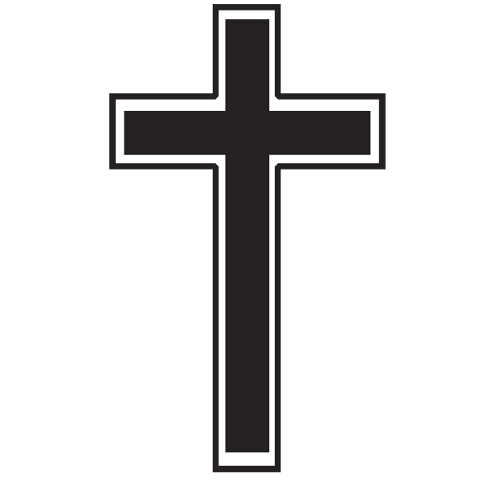

St. Timothy Sacramental Calendar
2023-2024

First Reconciliation Dates

11-4-23 Reconciliation workshop 9:30-11:30 am. Please be in the church with your
student by 9:30 am.

11-8-23 First Reconciliation 6:30 pm in the church.

First Communion Dates

2-24-24 First Communion Workshop 10:00 am - 12:00 pm. Please be in the church with
your student by 10 am.

4-3-24 First Communion Practice 7:00 pm in the church.

4-6-24 First Communion Mass 1 pm. Please have your student in the teacher’s lounge
by 12:30 pm.

